COMP 3612
Assignment #1: HTML + CSS

Version: 1.0, September 26, 2026
Due Friday October 9, 2026 at 6pm

Overview
This assignment provides an opportunity for you to demonstrate your ability to work with HTML and CSS. You will be creating three different HTML pages.

Beginning
It is your responsibility to read all the assignment instructions thoroughly and carefully. If you are unclear about something, ask me. But before you do, read the material in question again!
Starting files (images and data and instructions) can be found in the zip on D2L.

Grading
The grade for this assignment will be broken down as follows:
CSS (accuracy, effort, suitability) 50%
Semantic HTML 15%
Functionality (follows requirements) 35%

Data Files
Images have been provided. I have also provided a JSON text file which provides the text and data needed for the assignment pages.

Requirements
This assignment consists of three HTML pages with the following functionality:
- Your main assignment (home) page should must be named index.html.
- I have provided a text file named data.json that contains all (or close to all) the text that appears in the provided screen shots. You can copy + paste this text instead of re-typing all of it. I don’t care if you change the text; I only care that you have equivalent text blocks in the same places.
- If you make use of CSS recipes you found online, you MUST provide references (i.e., specify the URL where you found it or the prompt you used) via comments within your CSS file. Failure to properly credit other people’s work in your CSS will likely result in a zero grade. You can NOT make use of a third-party CSS library.
- Header. Each of the three pages will have the same header. Each link/item in the header should be a link with a hover style that changes the color of the text. The destination for the HOME link should be index.html, the destination for the ABOUT link should be about.html while the destination for the others should simply be dummy links to “#”.
- Footer. Each page in the assignment should have the same footer. My screen captures show one possibility, but feel free to change its look.

- Your home page (index.html) should look quite similar to that shown below. When I say “similar” I don’t mean “exactly identical” … different browsers, different browser widths, different platforms: all will affect the appearance somewhat. The purpose of this requirement is for you to learn how to implement a relatively straight-forward design relatively accurately. Notice the styling of the Home link in the header. The View Details button for the Cable Knit Sweater should navigate to product.html. Colors and sizes should be similar, but don’t have to be identical. I have also provided image files of these three screen captures.
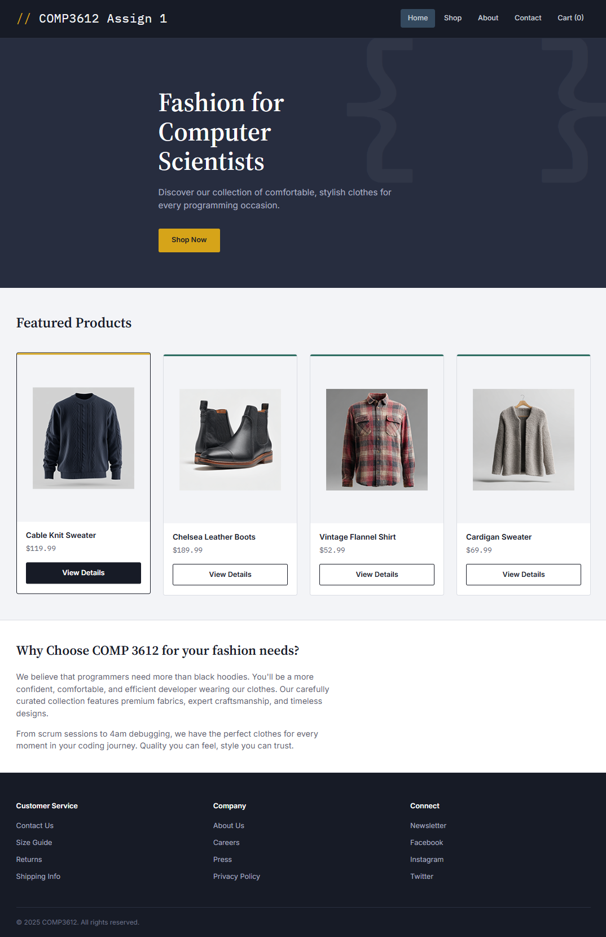

- Your about page (about.html) should look similar to the below image. Feel free to modify the text. Don’t forget to add images. Colors and sizes should be similar, but don’t have to be identical. Notice the About link in the header is styled differently. I ran out of page space so I clipped out the footer below, but it should have the same footer as the other two pages.
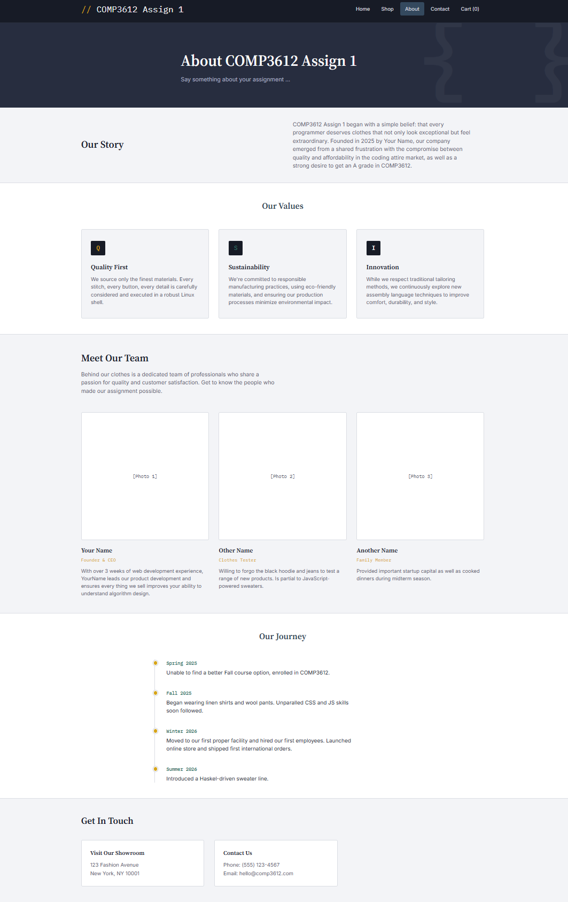

- Your sample product page (product.html) should look similar to the below image. Feel free to modify the text, but it should more or less follow the product information in the data file. The Add to Cart button should submit the form to https://www.randyconnolly.com/tests/process.php.
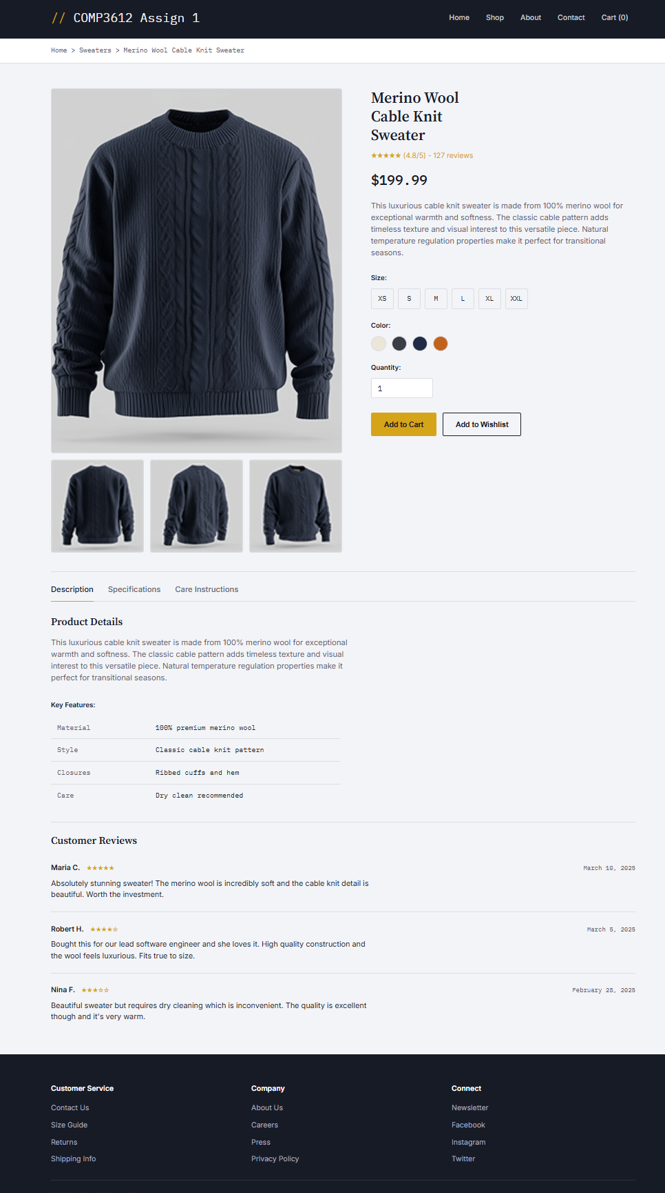

Submitting and Hosting
Your assignment source code must reside on GitHub and reside on a working public server (in this case GitHub Pages).
GitHub Pages works in conjunction with git and github. You push your html/css/images to github repo; and then push to the host. The instructions for doings so can be found at:
https://docs.github.com/en/pages/getting-started-with-github-pages/creating-a-github-pages-site
It is up to you whether you want your pages to be public (available to the world) or private (available to only those with access to your github repo).
If you are using a private repo, you must add me as a collaborator!
When your hosting is working and the assignment is ready to be marked, then send me an email with the following information:
- The URL of the home page of the site on github pages.
- The URL of the github repo so that I can mark the source code. If your repo is private, then add me as a collaborator!

Hints
- Part of your mark will be dependent on the sensible use of semantic elements.
- Your pages’ design should be similar to those provided. While this doesn’t mean identical, it does mean it should be pretty close. This is especially true for things like margins and padding and font size and family.
- Remember that layout will change with different browser widths. My screen captures used a relatively narrow browser width. If you expand your browser window to fill an entire wide-screen monitor, then paragraphs that are three lines long in my screen capture, might only be one line long on your wide monitor. This isn’t the type of “pretty close” I’m concerned with. Instead, I’m looking at things like padding, margins, font sizes, line spacing, font families, color, heights, etc.
- While you can implement these layouts with inline-block display mode, you will likely find grid layout (covered in chapter/Lab 7) is helpful.
- Don’t underestimate how long it can take to get a CSS layout working!!

